**COMSATS University Islamabad**

**Department of Computer Science**

**Mid Term Examination FALL-2021**

**Instructor: Zulfiqar Ali**

|  |  |  |  |
| --- | --- | --- | --- |
|  |  |  |  |
| **Course Title:** | *CSC339 Data Comm. & Networks* | **Maximum Marks**: | 40 | |
| **Dated:** | 17th November, 2021 | **Time Allowed:** | 1.5 Hour | |

*Note:* **Return your Question paper with your answer sheet:**

Name: _____________ Reg #:_______________

**SOLUTION**

**Problem #1 (04 points) CLO1**

What is the queueing delay at a network link with a link rate of 100 Mb/s, an   
arriving traffic rate of 9,000 packets per second an average packet length of 1250 bytes and a queue length of 500 packets?

The traffic intensity is 0.9, so the average number of packets in the queue is 9. Since the time needed to send one packet is 100 µs, the average queueing delay is 900 µs.

**Problem #2 (06 points) CLO 1**

In modern packet-switched networks, the source host segments long, application-layer messages (for example, an image or a music file) into smaller packets and sends the packets into the network. The figure below illustrates a switched network. Consider a message that is 7.5 ∗106 bits long to be sent from the source to the destination. (Assume header size is negligible relative to the entire message size). Suppose each link is 1.5 Mbps. Focus on transmission delays only and assume all other delay components are negligible.

(a) [3 points] Consider sending the message from source to the destination without message segmentation. How long does it take to move the message from the source host to the first packet switch? Keep in mind that each switch uses store-and-forward packet switching. What is the total time to move the message from source to the destination host?

(b) [3 points] Now suppose that the message is segmented into 5000 packets, with each packet being 1500 bits long. How long does it take to move the first packet from source to the first switch? When the first packet is being sent from the first switch to the second switch, the second packet is being sent from the source host to the first switch. At what time will the second packet be fully received at the first switch?

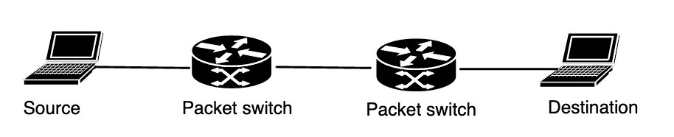

**SOLUTION:**

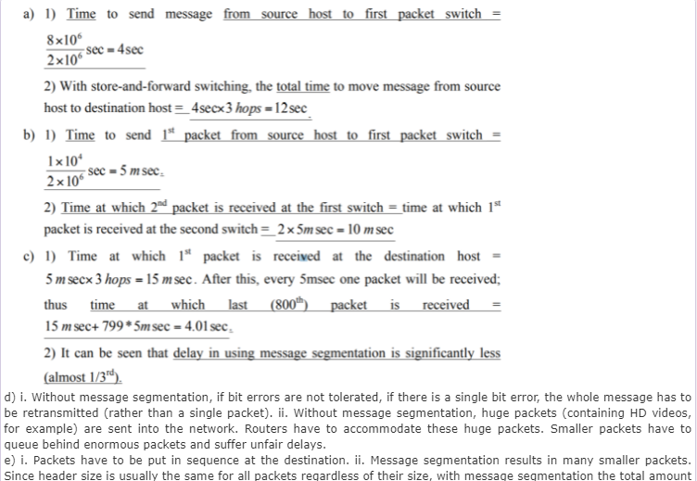

**Problem #3 (06 points) CLO 3**

A user in Chicago, connected to the internet via a 100 Mb/s (b=bits) connection retrieves a 250 KB (B=bytes) web page from a server in London, where the page references three images of 500 KB each. Assume that the one way propagation delay is 75 ms and that the user’s access link is the bandwidth bottleneck for this connection.   
a- [3 points] Approximately how long does it take for the page (including images) to appear on the user’s screen, assuming non-persistent HTTP using a single connection at a time (for this part, you should ignore queueing delay and transmission delays at other links in the network)?   
  
b- [3 points] How long does it take if the connection uses persistent HTTP (single connection)?

SOLUTION:

With non-persistent HTTP, there is one TCP connection for the page and one for each one of the images. Each connection incurs a delay of 2*RTT plus transmission time. Hence the total time until the page+images shows up on the user’s screen is calculated as follows:

RTT = 2 * 75ms = 150ms

Transmission Time = (Amount of data)/(data rate)

= ((250 Kbytes * 8 bits/byte) + (3 * 500 Kbytes * 8 bits/byte))/(100 x 10Mbits/sec)

= ( 2 Mbits + 3 * 4 Mbits) / (100 Mbits/s) (#RTT)*(RTT) + (Transmission Time) 2*(3+1) * 150 ms + (14 Mb)/(100 Mb/s)

= 8 * 150ms + (14 * 106 bits)/100 * 106 b/sec = 1200 ms + 0.14 sec = 1200 ms + 140 ms

= 1.34 seconds

b)

With persistent HTTP, there is only one TCP connection. The TCP connection handshake takes one RTT, this is followed by one more RTT to request the page, one more RTT to request the images, plus the transmission time for the page+images. Hence the total time for the page+images to show up on the user’s screen is equal to, 3 RTTs plus transmission time which is:

3*(2*75 ms) + 140 ms = 450 ms + 140 ms = 590 ms Suppose that user’s access router has a 4 MB buffer (B=byte) on the link from the router to the user.

**Problem #4 (05 points) CLO 3**

1. How many sockets does a UDP server need to communicate with 100 remote clients concurrently? How many port numbers does it need?

1 & 1

1. How many sockets does a TCP server need to communicate with 100 remote clients concurrently? How many port numbers does it need?

101 (1 listening socket and one socket per active client)    
1 port number is sufficient, as client sockets are identified by the 4-tuple (SA,SP,DA,DP)

1. How does the network stack identify the socket to which an incoming TCP data packet is to be delivered?

connection sockets are identified by the 4-tuple (SA,SP,DA,DP)

1. TCP socket is identified by how many attributes
2. How flow control is addressed in TCP/IP

**Problem #5 (06 points) CLO 3**

Consider the TCP reliable data transport protocol. The sender sends two packets, first one with 15 bytes of data and second one with 25 bytes of data. The initial sequence number is 107 and the first ACK is lost. Draw a space time diagram to show the sequence of events.

**Problem #6 (06 points) CLO 3**

The Transmission Control Protocol uses a method called congestion control to regulate the traffic entering the network. The behavior of TCP congestion control can be represented as a graph in which the x-axis indicates the time, and the y-axis indicates congestion window size. Please use the graph shown below to the answer the following questions. Note that the graph does not explicitly show  
timeouts, but you should be able to figure out when timeouts happened based on the events shown

(a) Slow Start: give two reasons why slow start is used, and explain why it does a better job than congestion avoidance for that function.

(b) Slow Start: identify the intervals of time when TCP slow start is operating. For each interval, identify which of the above reasons apply and do not apply and explain why.

(c) Congestion Avoidance: identify the intervals of time when TCP congestion avoidance is operating. Why should congestion avoidance be used instead of slow start during these intervals? Please clearly identify one specific reason.

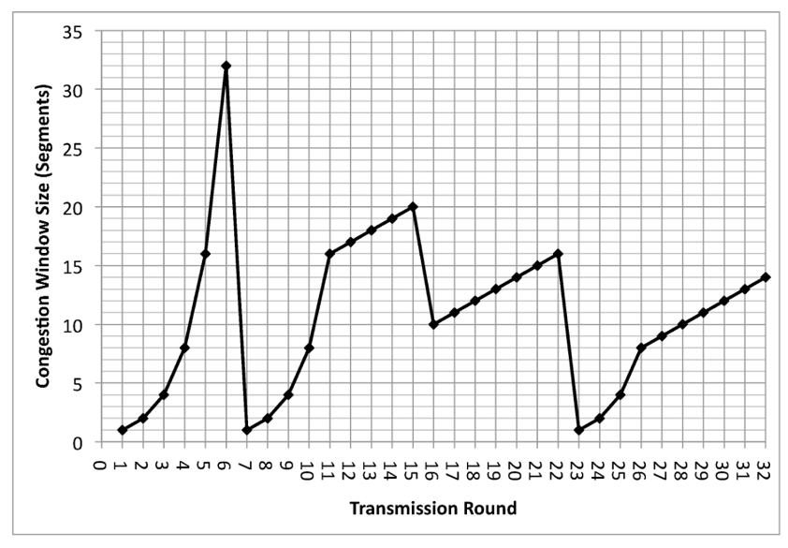

a. Identify time intervals where TCP slow-start is operating.

TCP slowstart is operating in the intervals [1,6] and [23,26]

b. Identify time intervals where TCP congestion-avoidance is operating

TCP congestion advoidance is operating in the intervals [6,16] and [17,22]

c. After the 16th transmission round, is segment loss detected by a triple duplicate ACK or by a timeout event?

After the 16th transmission round, packet loss is recognized by a triple duplicate ACK. If there was a timeout, the congestion window size would have dropped to 1.

d. After the 22ndtransmission round, is segment loss detected by a triple duplicate ACK or by a timeout event?

After the 22nd transmission round, segment loss is detected due to timeout, and hence the congestion window size is set to 1 (remember that this means that TCP can send up to 1 MSS ).

e. What is the *ssthreshold* value at the first transmission round?

The threshold is initially 32, since it is at this window size that slowtart stops and congestion avoidance begins.

f. What is the *ssthreshold* value at the 18th transmission round?

The threshold is set to half the value of the congestion window when packet loss is detected. When loss is detected during transmission round 16, the congestion windows size is 42. Hence the threshold is 21 during the 18th transmission round.

g. What is the *ssthreshold* value at the 24th transmission round?

The threshold is set to half the value of the congestion window when packet loss is detected. When loss is detected during transmission round 22, the congestion windows size is 26. Hence the threshold is 13 during the 24th transmission round.

h. What will be the values of *cwind* and *ssthreshold* if packet loss is detected after the 26th round by receipt of triple duplicate ACKs?

The congestion window and threshold will be set to half the current value of the congestion window (8) when the loss occurred. Thus the new values of the threshold and window will be 4.

**Problem #7 (7 points) CLO 3**

For network address 192.168.10.0 subnet mask is 255.255.255.224. Answer the following questions:

1. How many subnets does the chosen subnet mask produce? 8
2. How many valid hosts per subnet are available? 30
3. What is the broadcast address of each sub network?

**192.168.10.31**

**192.168.10.63**

**192.168.10.95**

**192.168.10.127**

**192.168.10.159**

**192.168.10.191**

1. What is the subnet address of each subnet?

**192.168.10.0**

**192.168.10.32**

**192.168.10.64**

**192.168.10.96**

**192.168.10.128**

**192.168.10.160**

1. If the destination address of the packet is 192.168.10.183, what is the sub network towards which this packet needs to be forwarded?

**192.168.10.160**

**Problem #8 (5 points) CLO 3**

If a packet is too long to be forwarded through a given network, it must be “fragmented”. Let’s consider a scenario where original packet No. 13 with 20 bytes’ header and 1400 bytes’ payload is sent through network with max packet size of 500B

1. How much data will be sent in each segment?
2. Router will divide the original packet in how many packets?
3. What will be the value of the following fields in each segment: (1) ID, (ii) offset, (ii) MF?
4. Can the source direct the network routers not to fragment the packet? If yes then by setting which attribute of the header?